

***Project Report***

***Course Code* :** **CSE415**

***Course Title* :** **Web Engineering Lab**

***Project Title* :** **Expense Recorder**

**Submitted To**

**Ms. Nusrat Khan**

Lecturer, Course Teacher

**Department of CSE**

**Daffodil International University**

**Submitted By**

**Md. Nure Alom** (ID: **192-15-2791)**

**Mafia Islam Sinthia** (ID: **192-15-2815)**

Section: **55_PC-K**

**Department of CSE**

**Daffodil International University**

**Table of Content**

|  |  |
| --- | --- |
| **Description** | **Page** |
| **Cover Page** | **01** |
| **Table of Content** | **02** |
| **Overview** | **03** |
| **Project Team** | **03** |
| **Goals** | **03** |
| **Phases** | **03** |
| **Project Structure** | **04-05** |
| **Content Type Data** | **05-06** |
| **Page Template and Design**   1. Login Page 2. Signup Page 3. Home Page 4. Add New Expense Type 5. Add New Expense 6. My Expense List 7. Pie Chart View 8. Update Expense 9. Delete Expense 10. Profile Page 11. About Us Page 12. Database     1. users Table     2. exp_type Table     3. expense Table     4. chart_data View | **06-11**  06  07  07  07-08  08  08  08  09  09  09  09  10-11  10  10  11  11 |
| **Responsive Design** | **11** |
| **Coding Language Usages** | **12** |
| **Hosting** | **12** |
| **Deadline** | **12** |
| **Budget** | **12** |

**OVERVIEW**

Nowadays we spend a lot of small expenses which we don't account for when we go somewhere or travel; as a result we don't have much in hand for future savings in the month end. We also don't know the reason for the situation. As we don't track our small expenses, many times throughout the month, we expense a lot that is much more than we can imagine. But we can easily reduce unnecessary expenses if we have a record of every expense throughout the month. To help and improve empty hand situation, we build this application called "Expense Recorder".

The purpose of this application is to save the records of a user expenses throughout the month. This will help the user to track expenses by types and for future savings, user can easily take decision what expenses need to be reduced or modified. User will have a neat pie chart to track in which category and how much he expense.

**PROJECT TEAM**

* Md. Nure Alom --- CEO, Developer --- [nure15-2791@diu.edu.bd](mailto:nure15-2791@diu.edu.bd)
* Mafia Islam Sinthia --- MD & Developer --- [mafia15-2815@diu.edu.bd](mailto:mafia15-2815@diu.edu.bd)

**GOALS**

* Release the project by June 2023
* 2k new user within July 2023
* 5k new user within August 2023
* 2k regular user within August 2023
* Increase server capacity by 50% within August 2023
* Decrease false result show by 100% within August 2023
* Increase newsletter signups by 30% every month

**PHASES**

* Phase 0 → Develop and Distribute fully working website (Currently Working)
* Phase 1 → Basic expense recorder website (Current Project)
* Phase 2 → CRM Integration
* Phase 3 → AI Implementation
* Phase 4 → Affiliate with restaurants and food delivery service to serve the user

**PROJECT STRUCTURE**

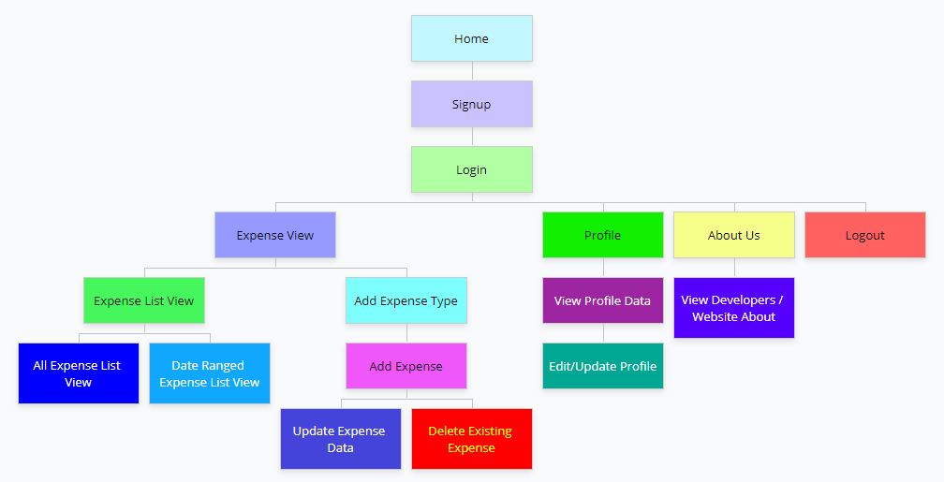

Fig: Project Workflow

* At the time of loading the application, user will be asked for username and password to login to his account in the **Login Page**. Using login credential provided in the signup page (*Username* and *Password*), user can login to an account. Here a warning message will be shown if user entered the wrong username or password. Forgot password is unavailable for now as we are building the application locally.
* A friendly **Signup page** is linked to the login page which is designed for the user to register a as a new user. In the signup page user will be asked for his *Full Name*, *Unique Username*, *Recovery Data* and *Password*. Here, unique username is a must and after every keystroke in the username input field, that username will be checked by the system for availability at that moment. For *unavailable username, a warning message* will appear in the signup page. Using unique & available username, user can sign up as the submit button will be in disabled mode if the username is not available. After signing up successfully, user will be redirected to *Login page*.
* After login, user will have the all of his expenses throughout the month in the **Expenses page**. If the user is new or didn't have any expense type, user will be asked for adding his own expenses type categories at first in the same page. Expense type adding date will automatically generated by the system. Expense type and date along with the user id will be saved to database.
* After adding at least one expense type, user can add expenses selecting desire category from **Add Expense modal**. *Payee*, *Amount* and auto generated *Current* *Date* along with the user id and expense type id will be recorded to track user and expenses type for future use.
* Users have access to view his all-time expenses and user also can select date range of his expenses to view in the expenses page. For better understanding a **pie chart** will be generated by the system using categorized expenses type and expense percentages will be shown in the pie chart by category.
* User can also see profile information from **Profile page** linked in the navigation bar and update any information from that page if want to.
* Users have access to view developer information from **About Us page**.
* All of the operation will check for user validity before loading or fetching data using encrypted user credential. A php build-in 64-bit encryption-decryption method will be used for user authenticity.

**CONTENT TYPE DATA**

Signup:

* Full Name
* Username
* Recovery Info
* Password

Login:

* Username
* Password

Add New Expense Type:

* User ID
* Authenticity
* New Expense Type

Edit Expense Type Title:

* Authenticity
* User ID
* Expense Type ID

Add New Expense:

* Authenticity
* User ID
* Expense Type ID
* Payee
* Amount

Update Expense:

* Authenticity
* Expense Type ID
* Expense ID

Delete Expense:

* Authenticity
* User ID
* Expense ID

Profile:

* Authenticity
* User ID

Pie Chart:

* Authenticity
* User ID
* Expense Type ID
* Expense ID

**PAGE TEMPLATES AND DESIGN**

1. **Login page**

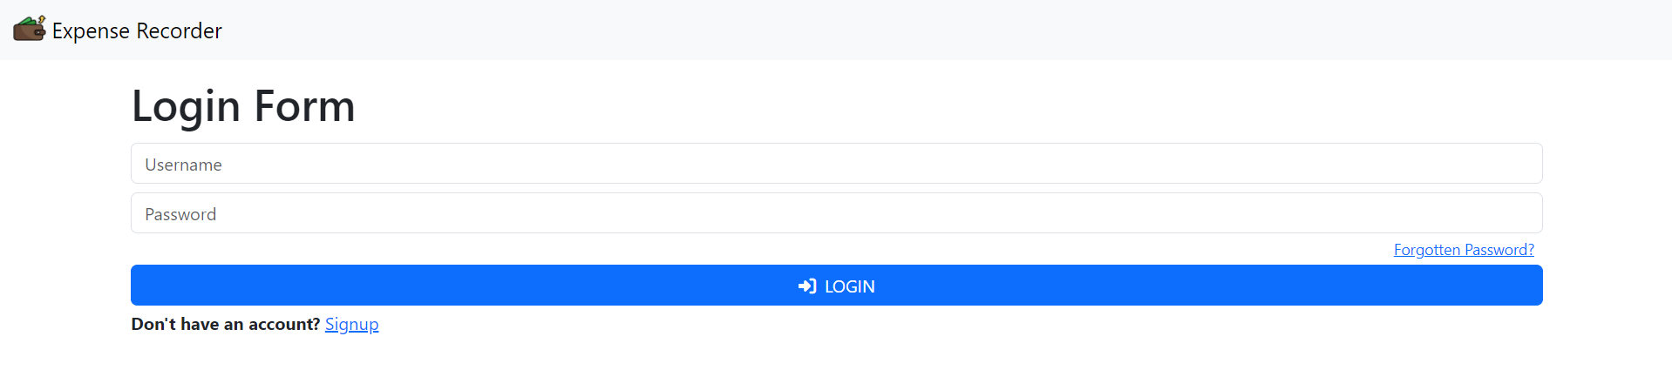

1. **Signup page**

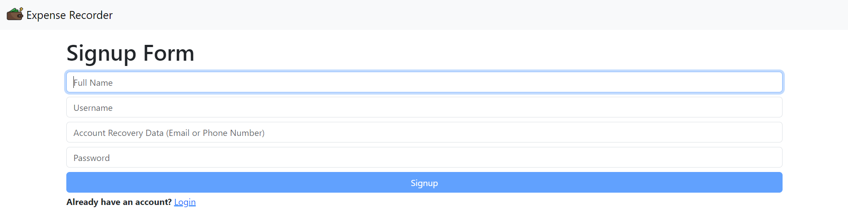

1. **Home page**

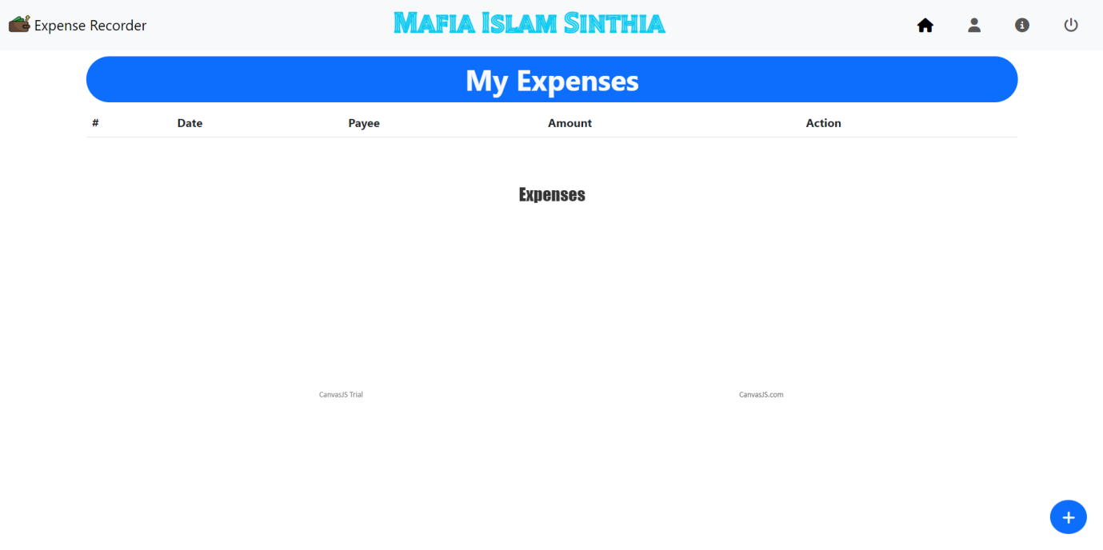

1. **Add New Expense Type**

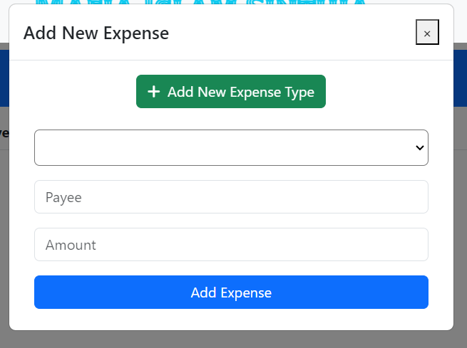 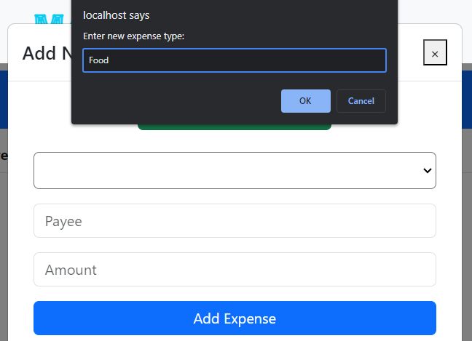

Fig: Add New Expense Type Option Fig: Prompt Box for New Expense Type

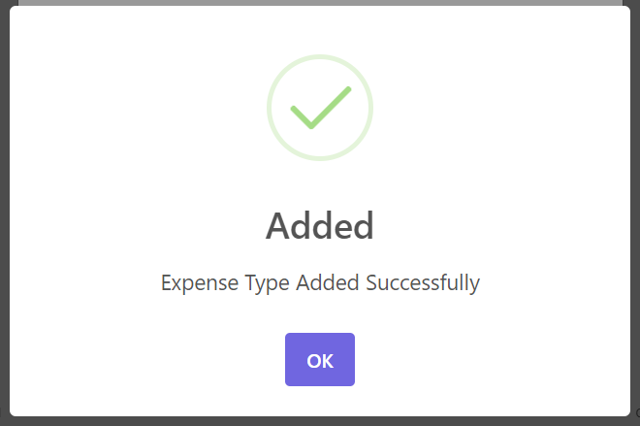

Fig: Confirmation for Expense Type addition

1. **Add New Expense**

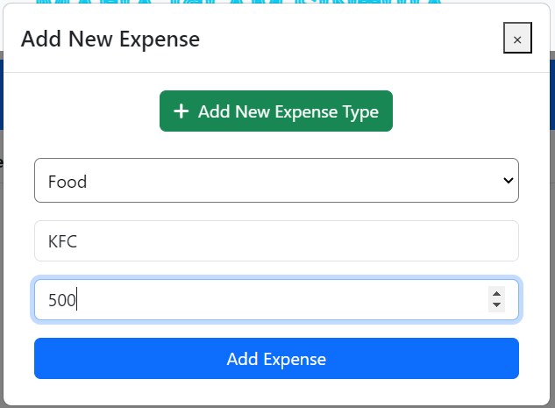 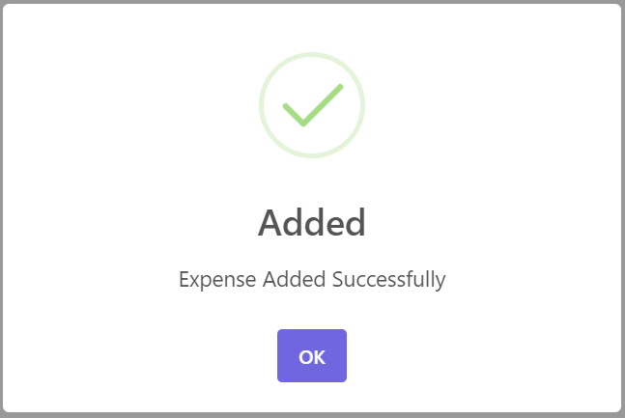

Fig: Add New Expense Modal Fig: Confirmation for Expense addition

1. **My Expenses List**

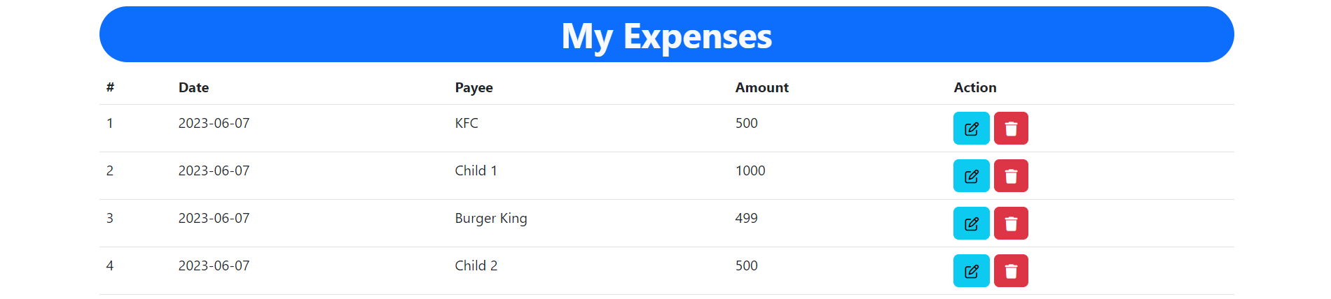

Fig: My Expense List view with update and Delete option

1. **Pie Chart View**

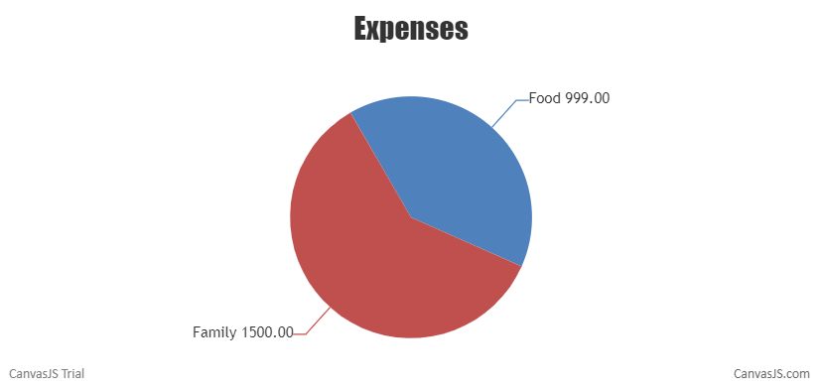

Fig: Pie Chart View according to Expense Type

1. **Update Expense**

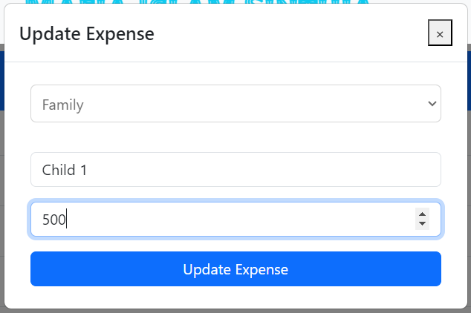 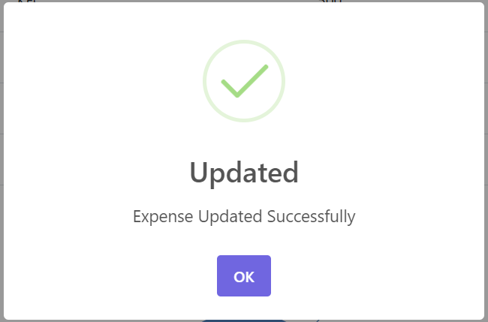

Fig: Update Expense Modal Fig: Expense Update Confirmation

1. **Delete Expense**

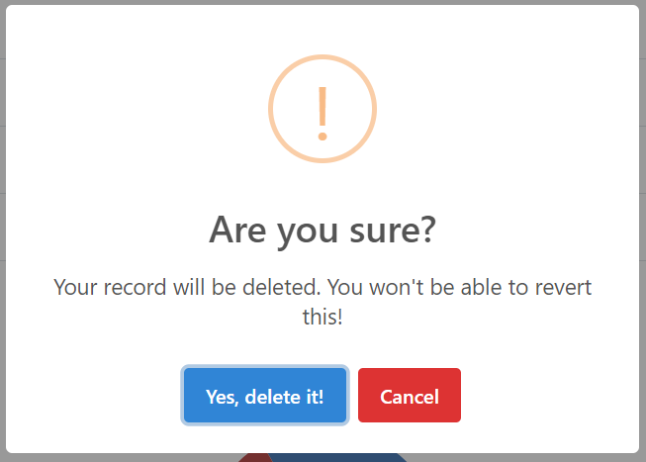 

Fig: Delete Confirmation from user modal Fig: Expense Delete confirmation alerts

1. **Profile Page**

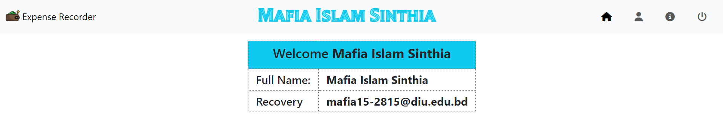

Fig: Profile Page with user Information Given in Signin Page

1. **About Us Page**

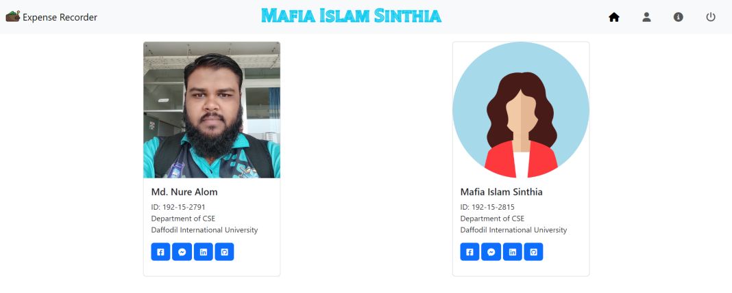

Fig: About Us page with Developer Information

1. **Database**

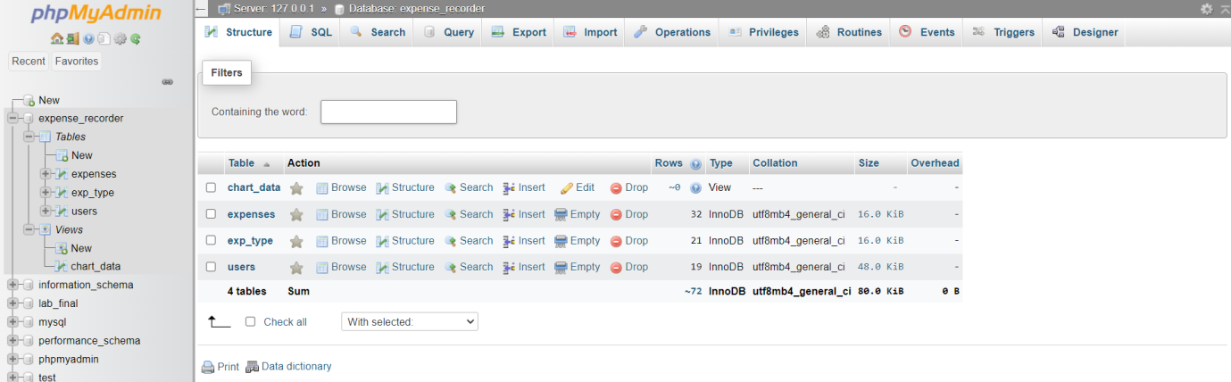

* 1. **users Table**

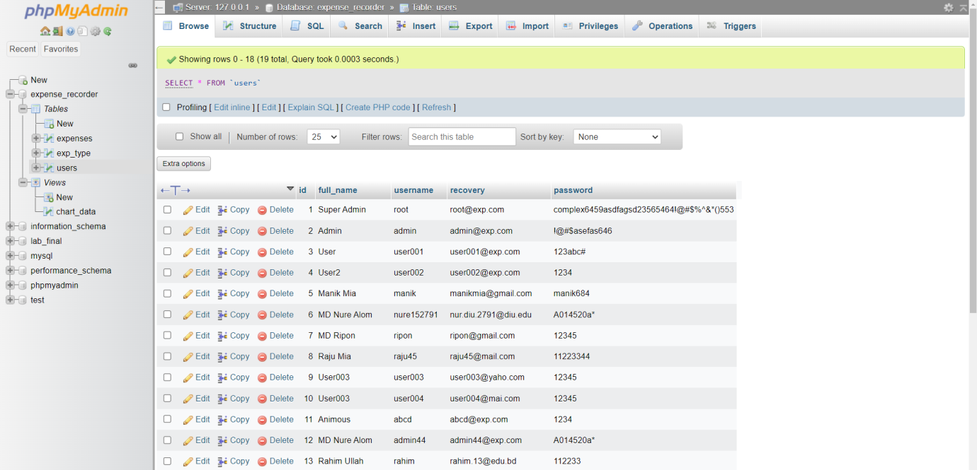

* 1. **exp_type Table**

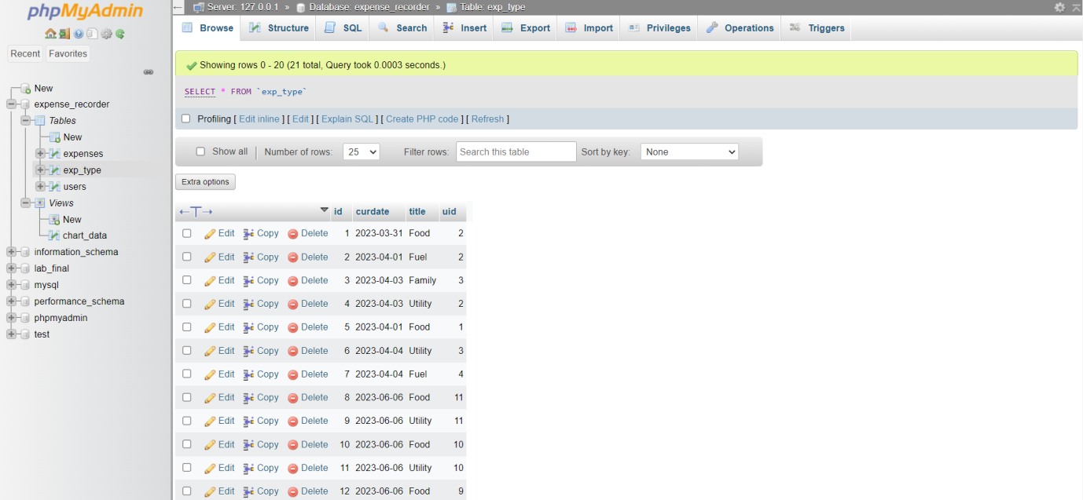

* 1. **expenses Table**

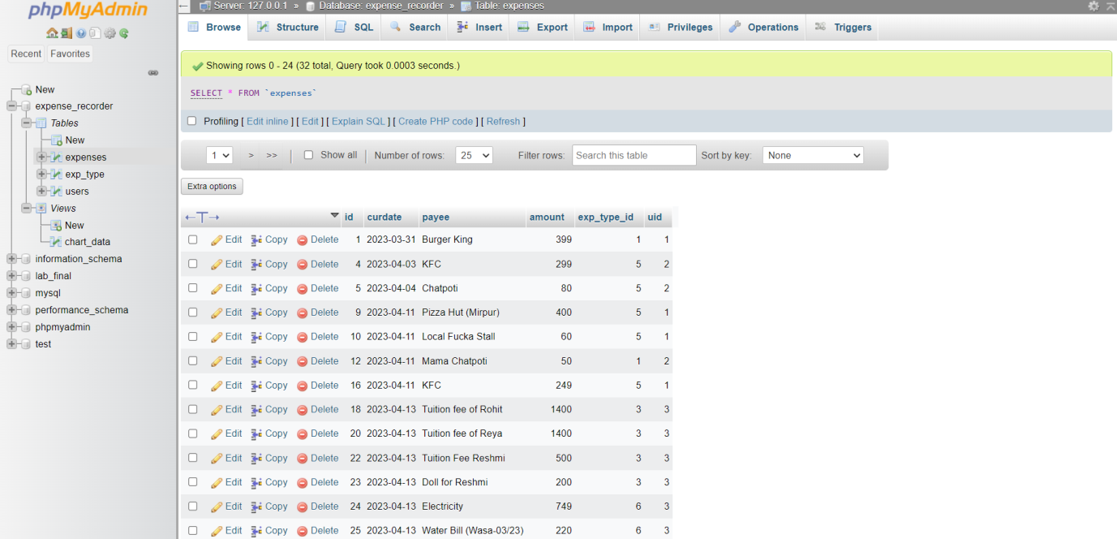

* 1. **chart_data View**

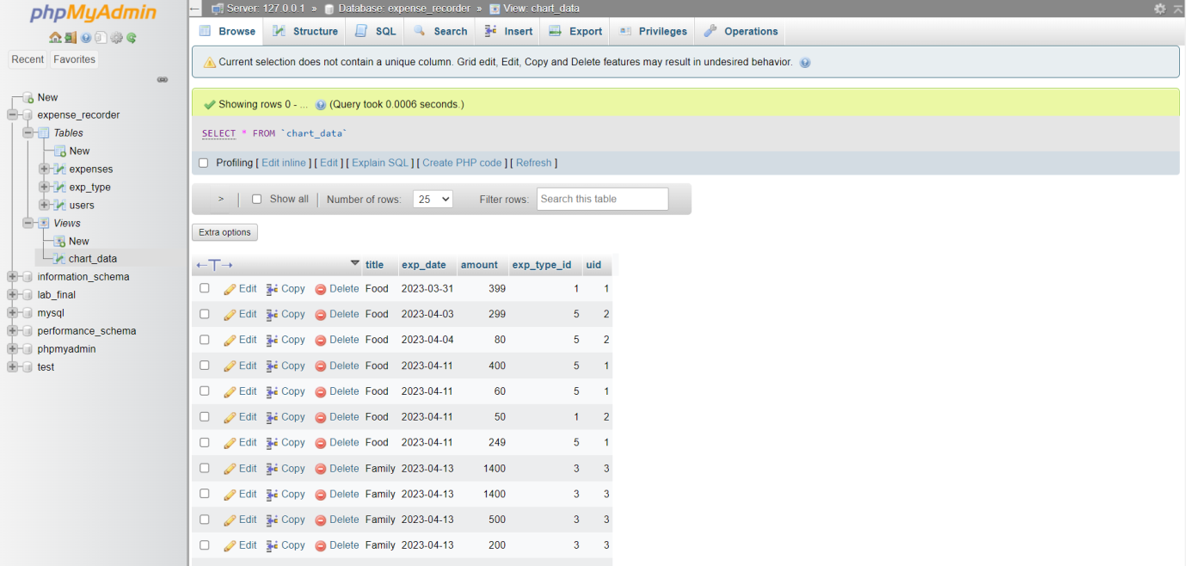

**RESPONSIVE DESIGN**

Responsive design for websites offers a multitude of benefits, including improved user experience across different devices and screen sizes, increased mobile traffic and engagement, cost and time efficiency by eliminating the need for separate versions, enhanced search engine optimization and visibility, improved conversion rates, adaptability to future devices, and simplified content management. By adopting responsive design, you can create a user-friendly and accessible website that adapts seamlessly to various devices, resulting in a positive user experience, higher engagement, and better overall performance.

For our website, responsive design is not that good till now. This is the next highest prioritized work after launch. Hope to implement this very soon.

**Coding Language Usages**

Front-End:

* HTML (Structure)
* CSS (Design)
* JavaScript (Validation)

Back-End:

* PHP (Server-Site Code)

Framework/Library:

* Bootstrap v5.3.0-alpha3 (Front-End)
* jQuery v3.6.4 (Perform cross-origin operations)
* Sweet Alert (Customized Alert Library)
* CanvaJS (Pie-Chart)
* XAMPP Control Panel (Local Server)

**HOSTING**

The project is under development. So, the project is hosted locally as the developers are within the same organization and locally connected using private network.

**DEADLINE**

Total time to implement the project is around six months. Starting from the January this year, we are expecting it to complete within June. Functionalities are under development and most of the word has done and majority of them passed the testing phase.

**BUDGETS**

As the project need much more research time, the budget is much more than usual. Approximate budget for this project from our site is around 3-3.5 lacks BDT.